**“CYBER BULLYING DETECTION”**

**1. ABSTRACT**

In this digital world, social media platforms are increasing day by day. Users who work online can share their information with ease using computers, cell phones, etc. However, this has led to an increase in criminal acts like online harassment, bullying, hate speech among youngsters. As a result, it has become a global problem.

Cybercrime includes harassing someone by sending harmful messages through social media, instant messaging, and digital messages. It turns out to be a group of insults, humiliations that can affect them and sometimes lead to suicide attempts in a very serious situation. To find out if someone is abusing or not and stop being abused, we created a project using a web page and machine learning (Naïve Bayes) algorithm to find and stop the person sending messages through those words.

To show how the process is taken place we used a web page in which the people can chat and if one person uses bad words, the words will change into *** and receive a warning to stop using the bullying words and those words are not shown to another user, if a user reaches the limit they will be blocked. In second method, If a user wants to send information via a URL link, then we classify the data based on the content they have posted if it is in category of bullying data. This is done with the help of Naïve Bayes algorithm code written in python, a web page with java as a backend and SQL database to save conversations and data. Therefore, with the help of this project, we can identify abusive words, stop bullying, and reduce criminal acts.

**2. INTRODUCTION**

Cyber bullying is a form of electronic technology that includes devices such as mobile phones, computers by networking, text messages, and conversations. It can happen online and text messages and images can be sent to a very large audience. Today's technologies are not just the cause of this. We use social networking sites for enjoyable work, such as connecting children with friends and family, helping students with school, and leisure. They can work to harm people. Bullying is going to have the same effect on both online and offline men. It is defined as "intended and repetitive damage done by electronic text." It focuses on children and teenagers, who are also interested in social media.

With Web 2.0 providing easy and open Internet connectivity, information protection has become a top priority. The Internet has changed much of human life: education, culture, diplomacy, ties, and so on. It affects someone's feelings: they feel connected, happy, loving, lonely, sad, afraid, and so on. Yet our lives are going to connect to the Internet. Social networking sites offer a wonderful and convenient forum for mankind to share thoughts, thoughts around the world. The number of social networks is increasing. Millions of people worldwide are using one or more social networking platforms. This statistic covers all genders, children, men and women. It's sitting at these social networking sites.

There are also wireless tools that enable connections and networking relationships. Most of the daily greetings, fun interactions and family relations took place behind the scenes. People are reaching out to others for support, compassion and affection, but animosity and hate have always been part of human society and have a profound effect on social history. In addition to being user-friendly and user-friendly, social networking will promote artistic and social events. Within these measurable conditions, we can see the harmful and unethical deeds committed on the dark side of human nature. Internet based media is pushing young people into an environment of systemic dangers, such as cyber-crime.

Cybercrime is found to be one of the most terrifying threats to any vulnerability; it affects all facets of state growth. Administrative departments, non-profit organizations, distant businesses and people are also targets of the cyber-crime culture. The "cybercrime business" functions as a true management mechanism at the international level, with technology practitioners meeting the general amount of evil that can be added to the market for billions of bonds per year. It is referred to as any other illicit crime that uses the machine as the principal means of unlawful activity.

**3. LITERATURE SURVEY**

**[2]** School bullying is a primary societal problem earned in recent years from academics. Several experts in the psychological and behavioral sciences have achieved the causes and consequences in particular. However, recent compromises have become commonplace: technology-savvy students shift to cyberspace to threaten their peers. This exploratory report examines the existence and possible impacts of individual trafficking on its victims and offenders on the modern environment. It also reports findings of pilot experiments to determine the existence and severity of online violence. It reports findings.

The overarching goal of this study is to eliminate this unusual divergence from computer-mediated communication and to create an environment in which rigorous future research can be carried out. Most men get raped in a day. A national study of 15,686 Grades 6 to Ten students revels in 1982, where about 11% of respondents were victimized, 13% were perpetrators, and 6% were victims of bullying during 2001. In Cleveland, around 49 fifth-grade students, Ohio, announced where one-fourth of their 1,088 students were victims of violence and bullying in 1989.

Findings were further verified by additional work carried out by the Family Work Institute via interviews with 1,000 adolescents in Grade 5 to 12. Analysis showed that 12 percent of teens were bullied five times more last month in 2002.

In 2002, 8 percent of teenagers aged 12 to 18 have witnessed bullying over a 6-month period, according to the Bureau of Justice Statistics. Conservative figures suggest that, every day (King 1982; Olweus 1978; Roland 1980) at least 5 per cent of those who go to primary and secondary schools (age 7–16) experienced bullying. Many young people are more likely to avoid bullying due to support or separation from friends or their families. It, though, cannot hold up to the ridiculous or normal or explain the suffering in large fragments or by disproportionate acts.

All of the perpetrators of abuse were afflicted by their thoughts of depression, alimentary conditions and chronic illnesses and offenders returned home. Intimidation has been a product of intimidation (e.g. Hawker & Boulton, 2000) that continues to perpetuate adulthood, reflecting the possible long-term consequences of childhood mistreatment (Olweus, 1994).

Serious situations of sexual attack and homicide, suicide, were referred to by perpetrators (Patchin, 2002; Vossekuil etcoll., 2002). The school department confronted the burden of coping with the abuse of its employees, following the shot and killed at Columbine High School in Littleton, Colorado, in 1999, with of adult teenagers concerned. Further research on school violence revealed that 71% (29) of perpetrators "felt threatened, harassed, or wounded by other people prior to the attack" in 37 cases involving 41 assailants between 1974 and 2000 (Vossekuil et al., 2002, p. 21). Torture played a limited function in their next brutal criticism. It was even decided.

Repeated violence may have certain very mild yet severe side effects. In the case of students bullying, for instance, school issues should be prevented, culminating in time lost or tiredness (BBC News, 2001; Rigby & Slee, 1999; Richardson, 2003). They described failure as an critical element in the battle against theft, dumping and other unintended consequences in literature on juvenile justice (Nansel et al., 2001; Garry 1996; Farrington, 1980; Gavin, 1997). Victims remain at danger depending on these results.

**[3]** Abuse term will be direct to an individual or group of people and exposing them to derogatory acts of bodily and mental will. This is a normal but sad and frustrating situation that each person experiences in their life.

With technology, the cyber-bullying approach known as Cyberbullying has spread far and wide in understanding the mass of innocent people. It involves computers, cell phones, etc. Abuse activities.

The emphasis of this paper is data mining or machine learning strategies suggested to identify and avoid cyberbullying and to locate the existence or absence of cyberbullying through the use of a database on a well-known platform for the social networks. We are still concerned regarding social problems surrounding cyberbullying and how to address the issue in these sectors. It also provides some tips to predict and deter possible Cyberbullying algorithms.

In this study, we have proposed a way to identify cyberbullying using machine learning. We checked our models for two SVM and Neural Network classifiers and used TFIDF and psychometric processing for the outputs using algorithms. They checked different versions of n-gram. We also reached exactly 92.8% with 3 grams of the neural network and 90.3% with an SVM of 4 grams for both TFIDF and sensitivity study. Throughout our neural network we have observed that the average performance is 91.9 percent higher than the SVM classifier and the SVM median 89.8 percent.

Furthermore, we will consider our neural network enhancing its classification by testing the consistency and precision of the data by contrasting our research with other work related to others with the same data. Our research can enhance the identification of cyber bullying and enable citizens use protection media by acquiring this precision. But, the scale of the training data prevents the identification of a cyberbullying trend. So, to boost efficiency, broad cyberbullying data are required. But, as seen by advanced machine learning approaches apart from large data, deep learning techniques are suitable for big data.

**[6]** Cyber bullying is not a form of abuse technology. While it has been a issue for a number of years, understanding of its effect on young people has only developed. Social networking platforms offer breeding ground for cyberbullying, and teenagers and adults who utilize such platforms are at risk of violence.

By machine learning, we will consider the linguistic trends used by offenders and their abusers and establish guidelines for the identification of cyberbullying. We also gathered the details that we used for our project on the www. FormSpring.me database, a database with questions and answers that include a large proportion of information utilized by many. They collected data using the cloud tool, Amazon Mechanical Turk. We use the details on the mark, use the machine learning techniques offered by the tooling device, to teach the program to identify the material used by others. All the C4.5 user graph and the model-based user could classify the true positive with an accuracy of 78.5 percent.

**Tip-1 : Preventing Cyber Bullying - Monitor Your Kid Online Tasks.**

In this digital age, children are growing up with technology in their hands. As a result, various forms of cyberbullying have become a domestic phenomenon. Teens and high-risk teenagers are vulnerable to abuse because they have a poor perception of good versus wrong.

This is your duty as a parent to learn about your child's online behavior and avoid cyberbullying. Know the child's devices and streaming platforms. It is necessary to insure that your child becomes more interested in offline activities than tech addiction, online games, and smartphones.

**Tip-2 : Preventing Cyber Bullying - Notice the Marks.**

The below are few signs that your kid is being cyber bullied.

* Potential rising or declining mobile phone, laptop or tablet use of your infant.
* Demonstration of emotional responses, such as sorrow, frustration or excitement at their computer activities.
* The propensity to block online conversations.
* Hiding on the computer of the system when others are nearby.
* Indifference of public facilities, committees and outdoor events.
* Sudden locking and activation of their social networking pages.
* Depressed and withdrawn

**Tip-3 : Steps to Prevent Cyber Bullying - Steps That You Can Take After Action.**

If you see some of the signs mentioned above, it may suggest that your ward is engaged in a sort of cyberbullying.

In the unlikely case that your child is witnessing cyberbullying, it is crucial that you take appropriate action to express your concern and report it. The following is one thing you should do if your kid or parent is the survivor.

**[9]** In addition, with technical advancements, online abuse is becoming more widespread. Bullying is a societal phenomenon where a person is bullying the Internet. These problems have generated fresh obstacles for implementation, the avoidance of anything like this, as it is not enough to use conventional approaches, such as the detection of suspects and the compliance of restraining orders. Internet-stalkers and cyberbullies are running on the Web without fear of repercussions and potential victims.

This paper explores the existence and extent of cyber stress and cyberbullying and the effect on the behavior of the individual. This work will help you identify other ways to avoid such violence online. Plays, Academics and Parents claimed that "Cyberbullying should be viewed like a criminal when transmitting texts and offensive comments via a mobile phone or the Internet." Investigations, regulations and research in the sector are pending. Specific concepts and basic principles that better define and monitor what we find to be e-media harassment and online correspondence for monitoring purposes. It includes penetration, the purpose of harming the individual.

* **Dragging and bowing:** This category includes sending messages that contain occult, obscene, or angry messages.
* **Exterior**: For malicious reasons to remove the user in a group.
* **Ratings**: Create online accounts on Facebook, Twitter or other social networking platforms as someone else to offend the credibility of the victim.
* **Betting:** A collective of individuals who make up a gang who give the victim's network hundreds of texts. This is like an opposition to service problem.
* **Directions:** To upload or delete awkward and humiliating things such as personal email, pictures, etc. Concerning one human to another and undermining one's view.
* **Check-out:** To embarrass or hurt someone, without that person's consent, give or publish private details about others.

**Abuse:** Sending tormented texts to someone else.

**4. PROBLEM STATEMENT**

In present digital era the use of online information sharing in increasing tremendously and it is leading to the cybercrime so to stop that we have introduced a project as a web technology which can be used by a persons for sharing information in healthy and safe conversations. As this project has the technology to stop the person sending abusive words and not shown to users and the words are identified with the help of Naïve Bayes algorithm and classify the data posted.

**4.1 Modules description**

**Admin :** Admin can view the users who have account. They can add the bullying words all the time. They will access and unblock any of the disabled users.

**User :** User can upload the data in the form of images and text and view on timeline. They can chat with the person by sending them the friend request and accepting them.

**Database :** The database is used to store the data about the users there images and messages. It shows the bullying words and categories.

**5. PROPOSED SOLUTION**

**Naive Bayes Algorithm**

This preaches the Naïve Bayes classifier on the principle of Bayes. It's a clear presumption of liberty. It is often referred to as an autonomous function pattern. Checks the chosen feature is present by the group function that will pick the other features that are present or not in the class. They also teach naive Bayes classifier is also in controlled learning to set up. It uses the techniques of optimum resemblance. We operated in a dynamic global environment. A touch of coaching data is needed. It is calculating the criteria for classification. The variation would be calculated by each gender. It does this when the inputs are small, gives feedback in an additional sophisticated shape, and displays the probability of each input attribute being from a predetermined state. The classification of Naïve Bayes should help machine learning and results.

**Bayes theorem : -** P(A|Y) = P(Y|A)* P(A)

P(Y)

Where,

* P(A|X ) is posterior probability/likelihood of A conditioned on Y
* P(Y|A) is posterior probability/likelihood of Y conditioned on A
* P(A)is prior probability/likelihood of A
* P(Y) is prior probability/likelihood of Y

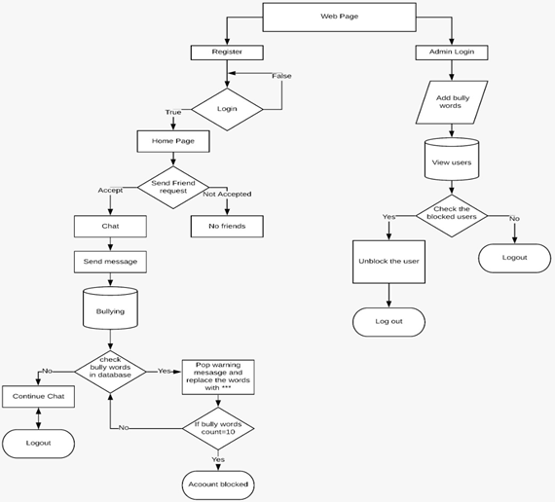

Fig 5.1 : Architecture

**6. RESULTS AND DISCUSSIONS**

This project program is deployed in a system with the Python, MySQL, Tomcat and Java software. It is shown as the web site using Web Technology like Html, CSS, Java Script for better understanding purpose. Open this program on Chrome for better results and proceed with the login and continue to chat.

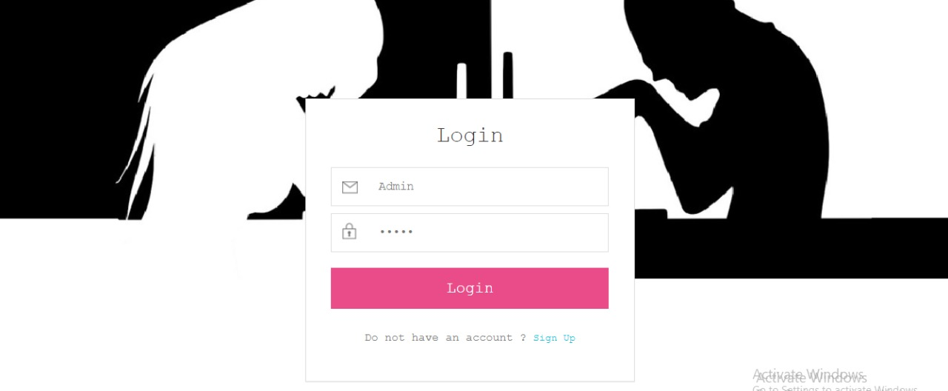

Fig 6.1 : Admin Login page

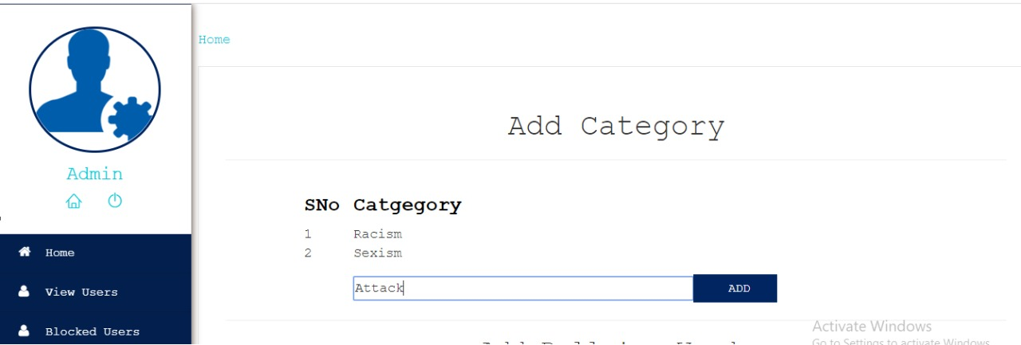

Fig 6.2 : Adding categories into the database

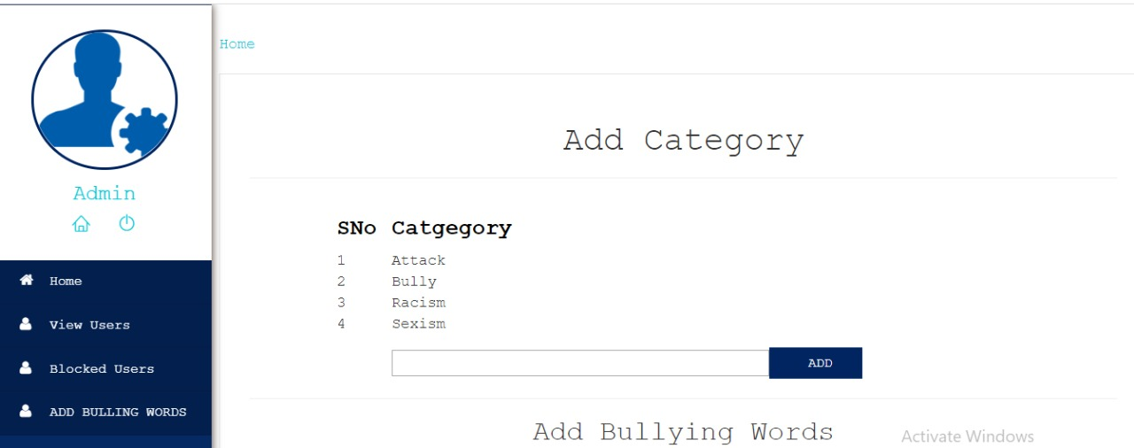

Fig 6.3 : List of categories

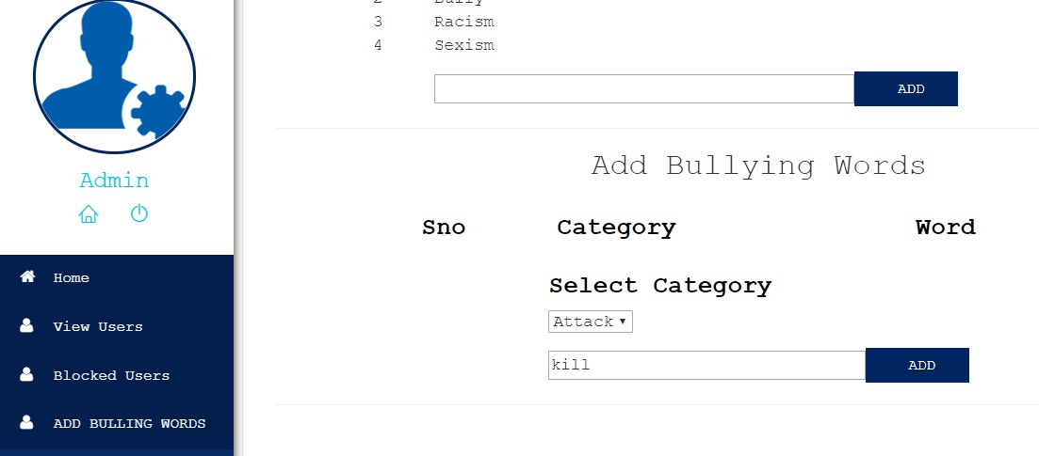

Fig 6.4 : Adding the words to categories

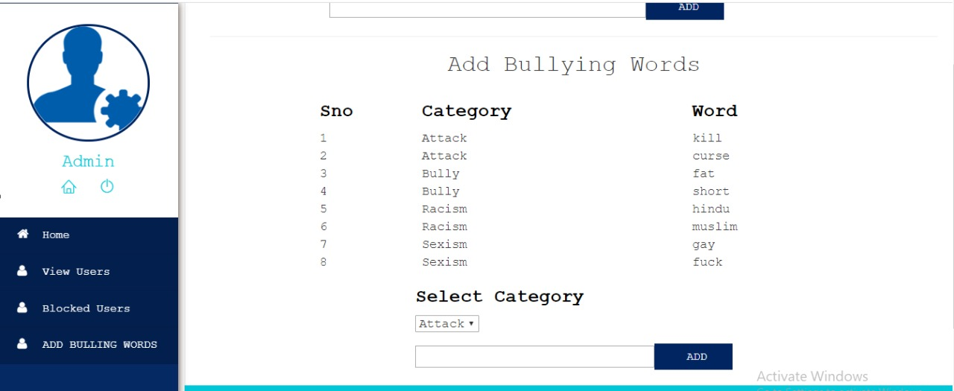

Fig 6.5 : List of words after adding



Fig 6.6 : Viewing the users registered

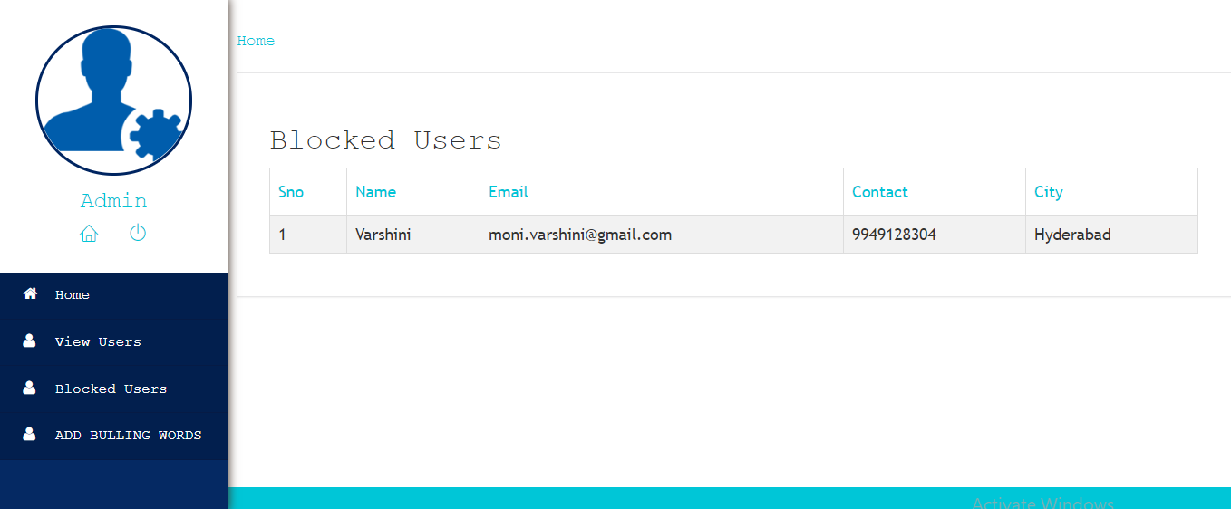

Fig 6.7 : Admin can view blocked users



Fig 6.8 : User registration form to Signup



Fig 6.9 **:** User uploading image



Fig 6.10 : User login page



Fig 6.11 : Welcome page for user

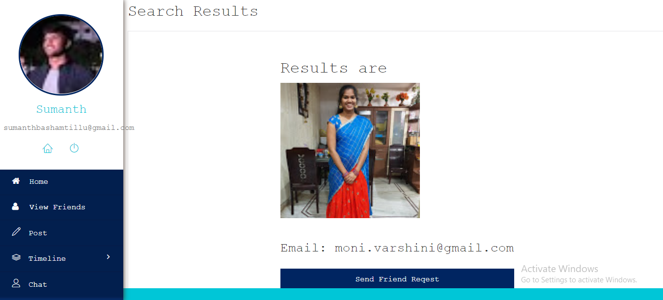

Fig 6.12 : User1 searching friends in view friends and sending friend request

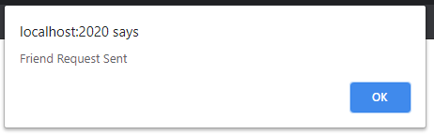

Fig 6.13 : Popup after sending request



Fig 6.14 : User2 getting friend request and can choose accept or reject

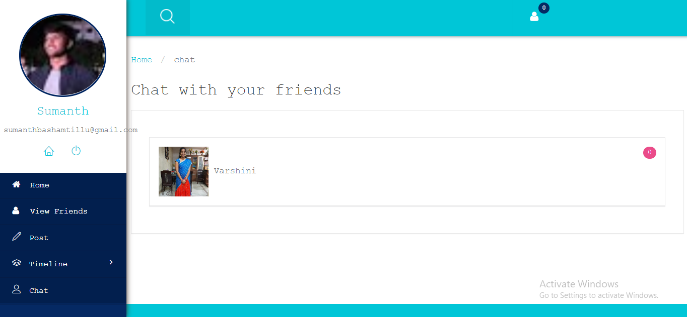

Fig 6.15 : User1 can chat with user2

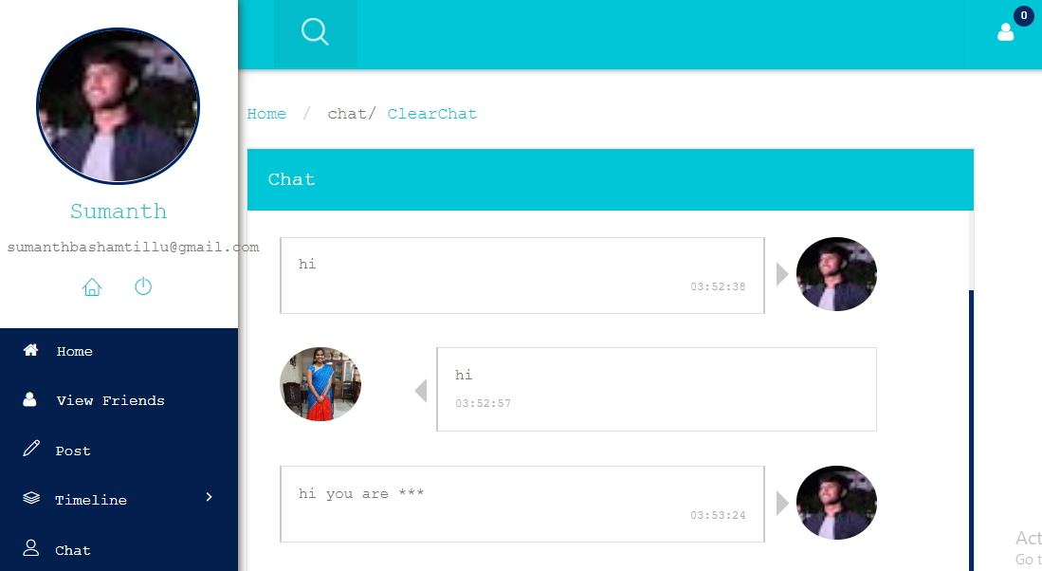

Fig 6.16 : Bullying words are replaced with ****

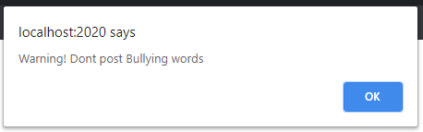

Fig 6.17 : Warning message

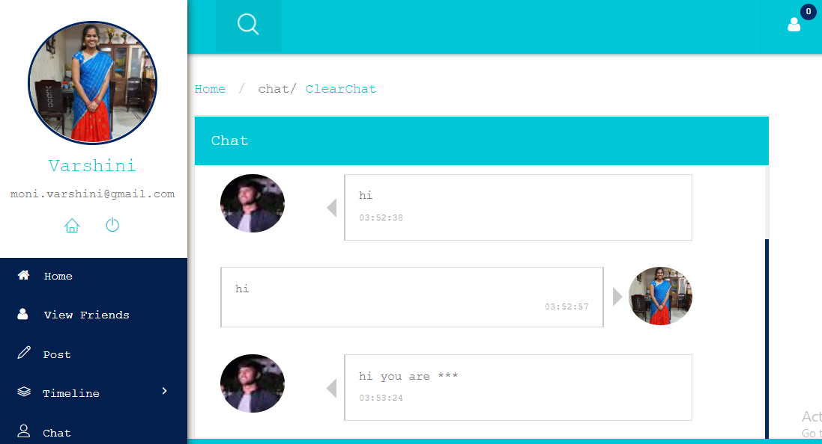

Fig 6.18 :User 2 cannot see the message



Fig 6.19 : User can post any image or text like (URL)

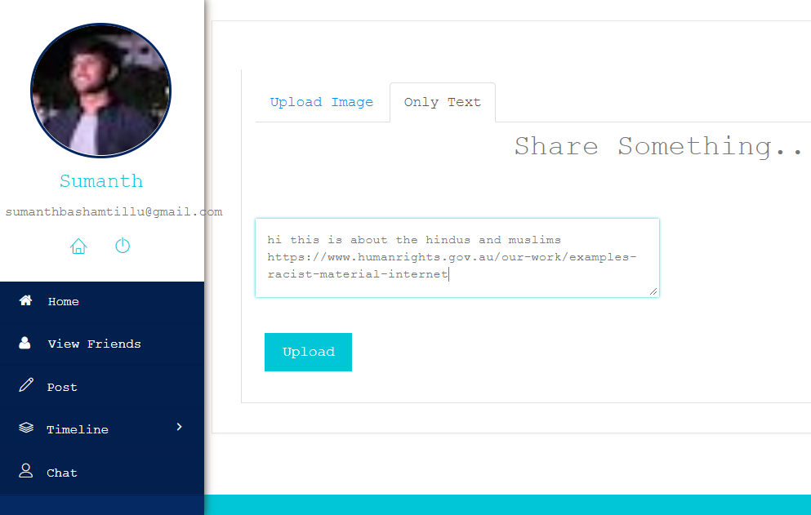

Fig 6.20 : Posting the text and URL

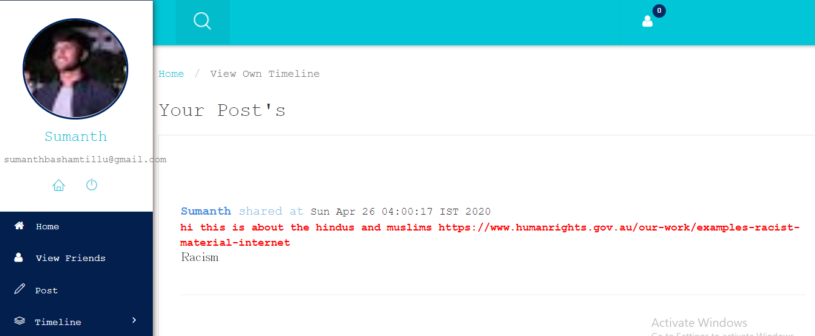

Fig 6.21 : User can view all the posts in the timeline and they are classified based on the category with the Bullying words.

**7. Conclusion**

Nowadays we can observe a lot of increase in the usage of internet and interaction between the people. As a result, there are lots of problems which affect the user. All social technology leads to an increase in Cyber bullying. In our project, we illustrated a method to reduce the Cyber bullying by using Naïve Bayes algorithm in machine learning to detect the Cyber bullying. This method will help in detecting the messages which are bully and can help the environment in making the people safe.

So, this technique can able to stop the person from using abusive words and stop harassing. By classifying the content present within the URL, we can make another person from not opening any bad content and securing them.

So these methods can be accurate when there are extensive data sets and new algorithms. We can perform sentiment analysis on the social media data by extracting data from various social networking sites using the datasets and tools for verifying the words and sentence to identify the Cyber bullying. Weka, Rapid miner, R, Orange are some tools which can be useful for this purpose. The accuracy of Cyber bullying detection may reduce if we have limited data sets. We can carry research out with alternative methods and additional data sets to detect all the awful words and update them to gain more accuracy and classify them.

As mentioned before, there is labeled data with very few datasets are available, so for the future purpose, we can improve by collecting more datasets. We can also include the images and develop this web page to stop the person from not sending images that hurt the other person and make a good user-friendly app where a person can chat or share the useful information and in effect.

**8. References**

[1] https://www.stopbullying.gov/cyberbullying/

[2] J.Patchin, & S. Hinduja, "Bullies move beyond the schoolyard; a preliminary look at cyberbullying.” Youth violence and juvenile justice.4:2 (2006). 148-169.

[3] Sourabh Parime, Vaibhav Suri “Cyberbullying Detection and Prevention: Data Mining and Psychological Perspective”, 2014 International Conference on Circuit, Power and Computing Technologies [ICCPCT]

[4] http://www.TIMESOFINDIA.com

[5] http://www.ncpc.org/cyberbullying

[6] K. Reynolds, A Kontostathis, and L. Edwards, "Using Machine Learning to Detect Cyberbullying," In Proceedings of the 2011 1Oth international Conference on Machine Learning and Applications Workshops (ICMLA 2011), vol. 2, December 2011. pp. 241-244.

[7] http://www.statisticbrain.com/cyber-bullying-statistics/

[8] http://en.wikipedia.org/wiki/Cyber-bullying/

[9] A. M. Chandrashekhar, Muktha G S & Anjana D K, “Cyberstalking and Cyberbullying: Effects and prevention measures” Imperial Journal of Interdisciplinary Research (IJIR) Vol-2, Issue-3, 2016 ISSN: 2454-1362

[10] R. Cohen, D. Y. Lam, N. Agarwal, M. Cormier, J. Jagdev, T. Jin, M. Kukreti, J. Liu,K. Rahim,R. Rawat, W. Sun, D.Wang, M.Wexler, “Using Computer Technology to Address the Problem of Cyberbullying”, SIGCAS Computers & Society | July 2014 | Vol. 44 | No. 2